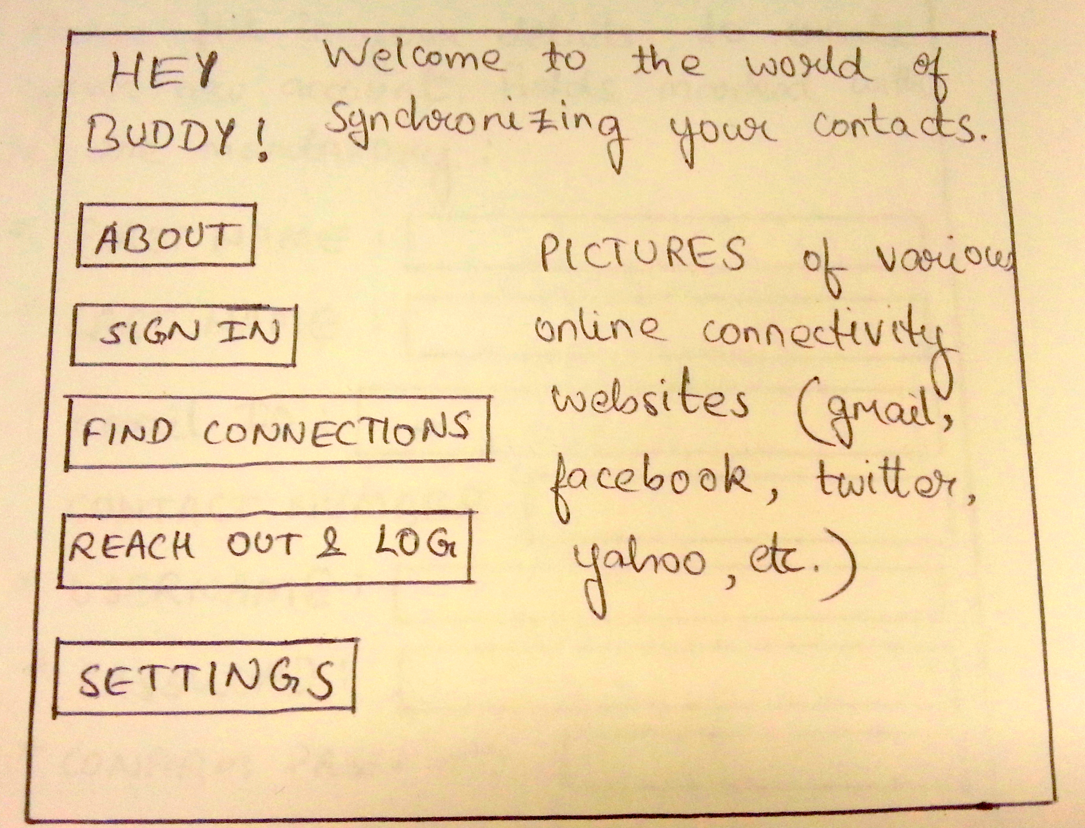

Hey Buddy! Aims at synchronizing your contacts from the various online connectivity websites su(changed)ch as Facebook, Gmail, Yahoo, LinkedIn, Twitter, etc. It enables you to import your contacts, reach out to your contacts and keep a record of the last time you reached out to any contact. You would be able to set up automated reminders to help you stay in touch and follow-up with people in a timely manner. It is an easy-to-use interface for regular communicators.

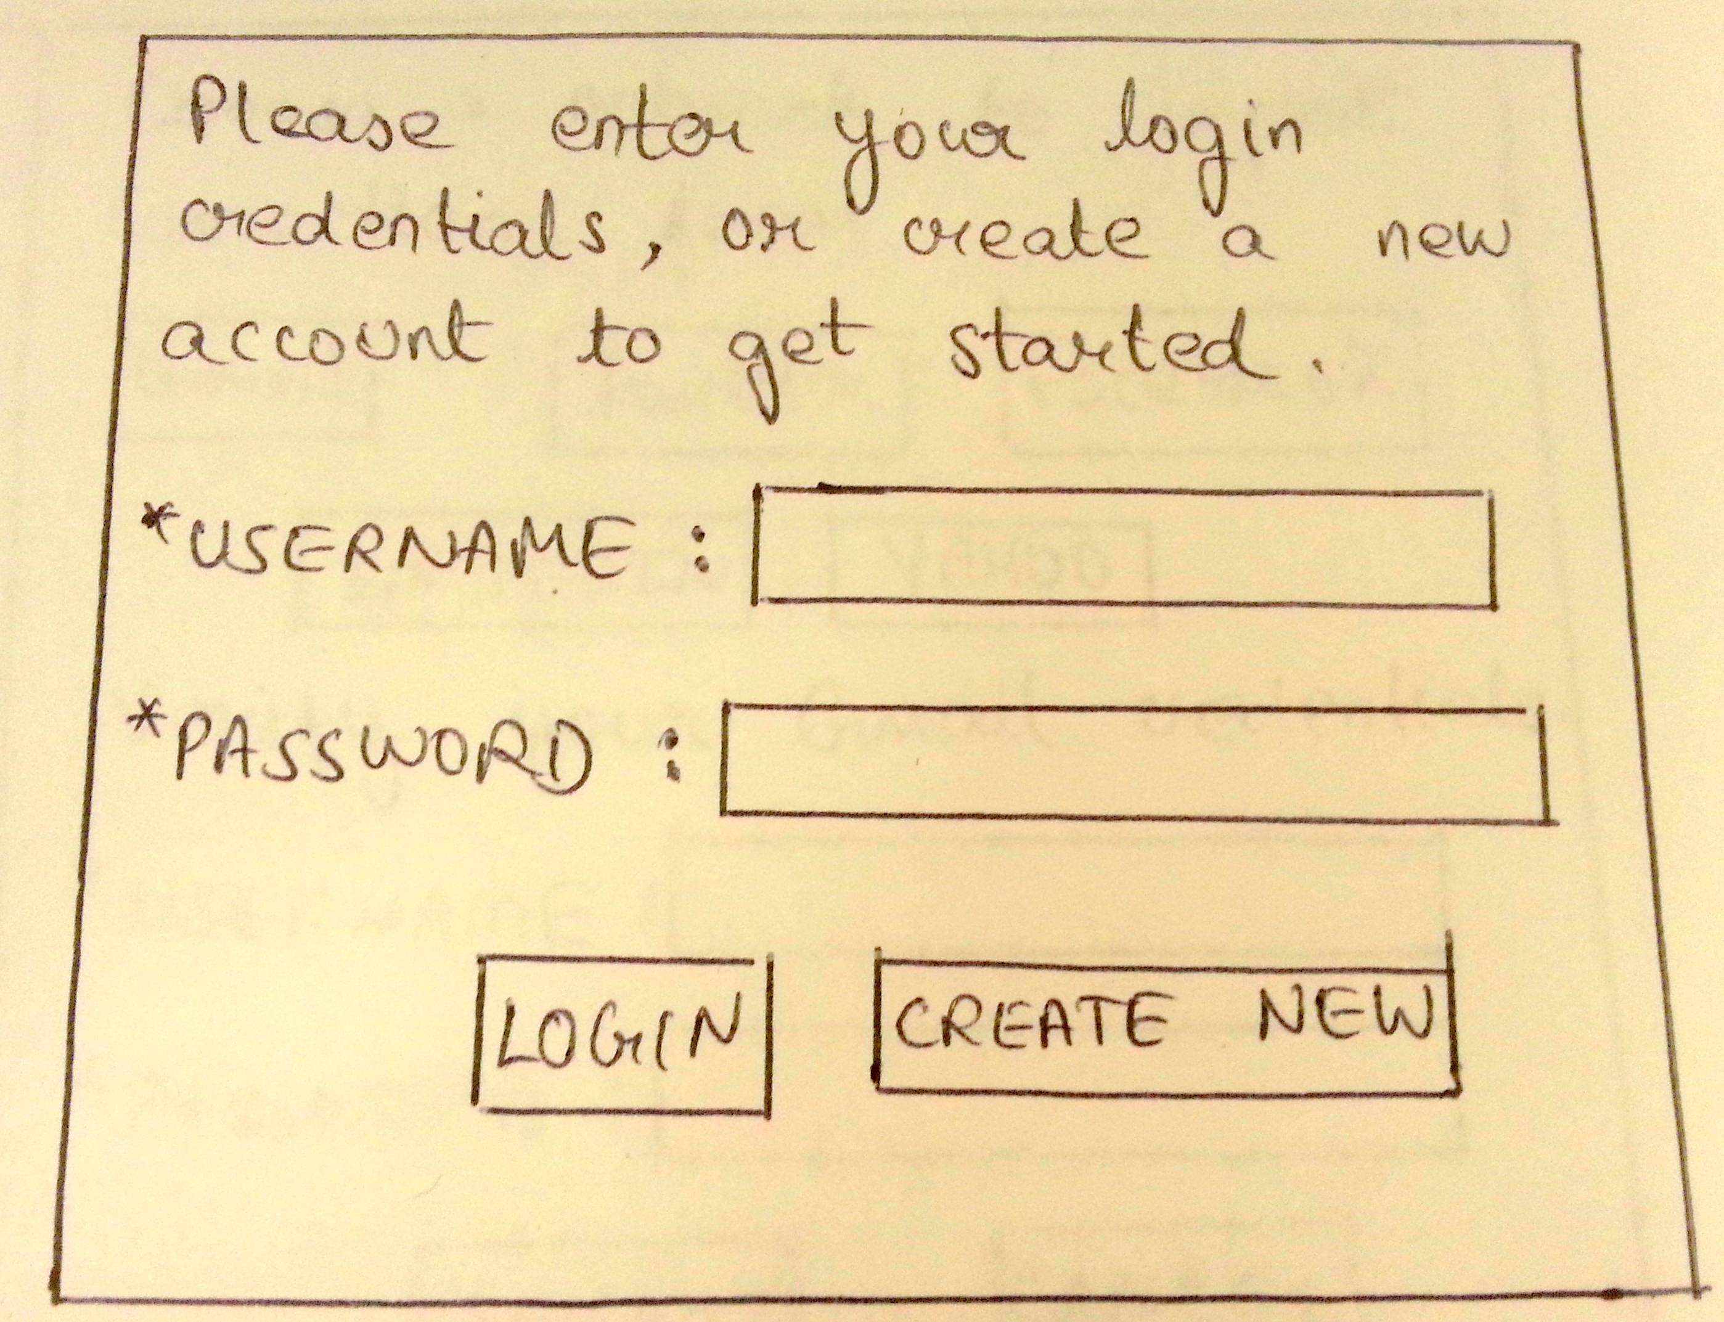

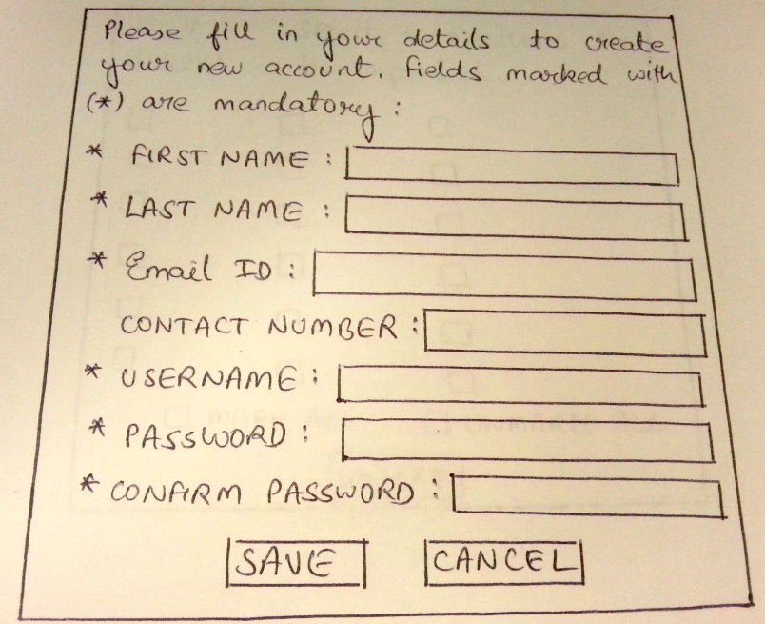

Click on the sign-in tab on the home page and login with your credentials, or if you are a new user, create your account with us to get started. Fill in your first name, last name, contact information, choose a username and set a password for your account. Save your information and continue to importing your connections and reaching out.

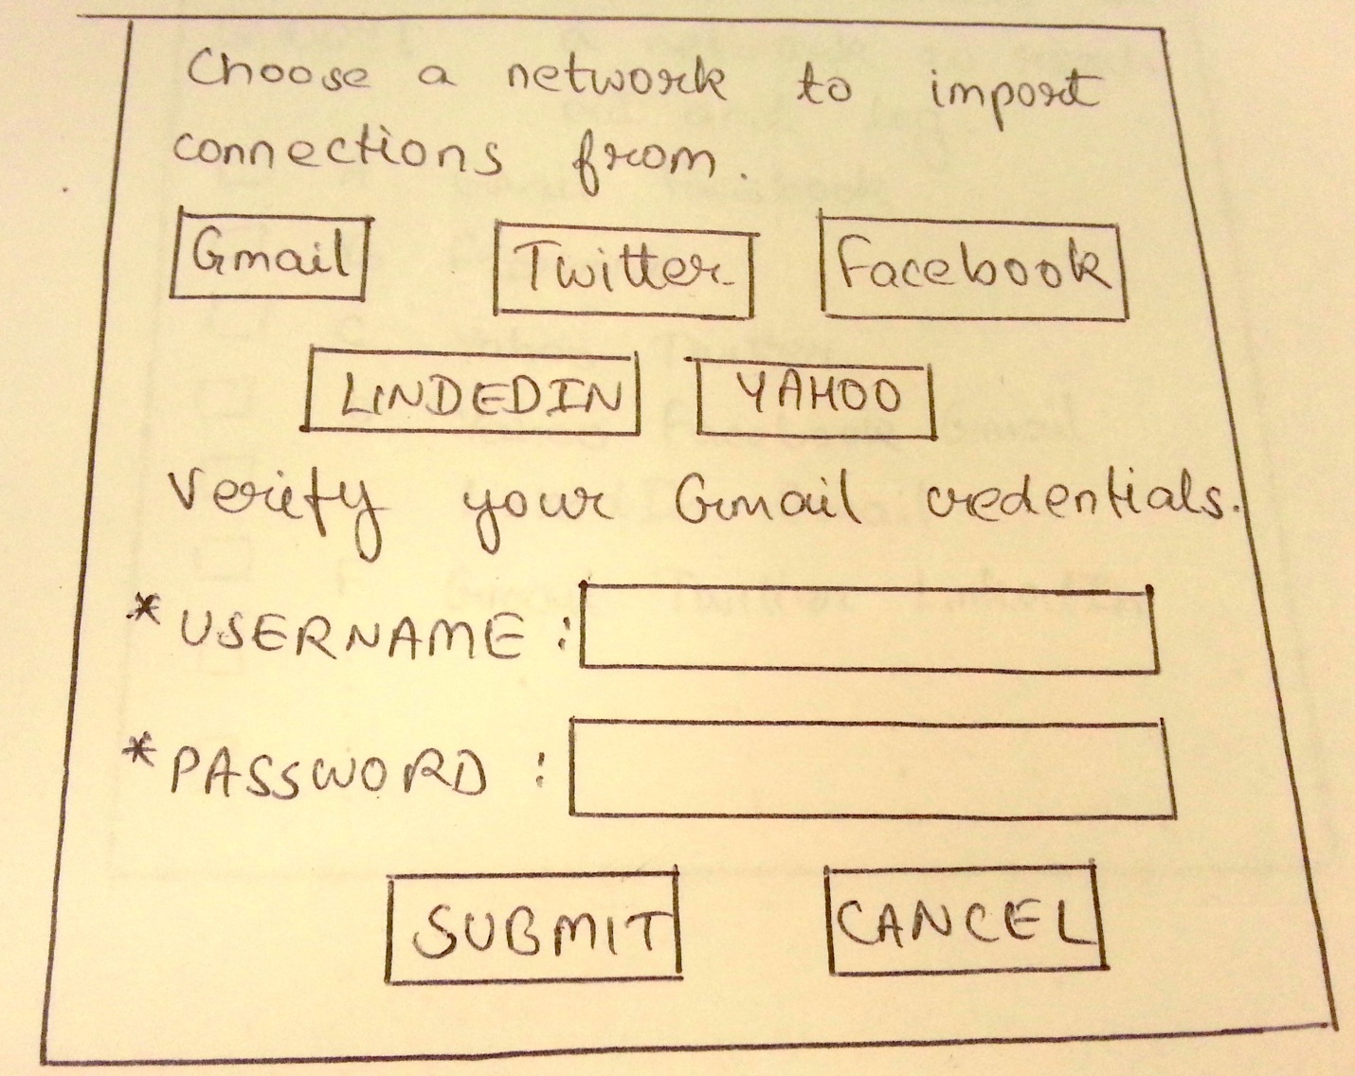

Click on the network you wish to import your connections from and verify the corresponding account credentials. On verification of your details, Hey Buddy would redirect you to the chosen network and enable you to choose the connections you would like to import. For example, clicking on “Gmail” will enable you to enter your Gmail login credentials, upon verification of which, you would be able to select people from your conversations that you would like to import to Hey Buddy.

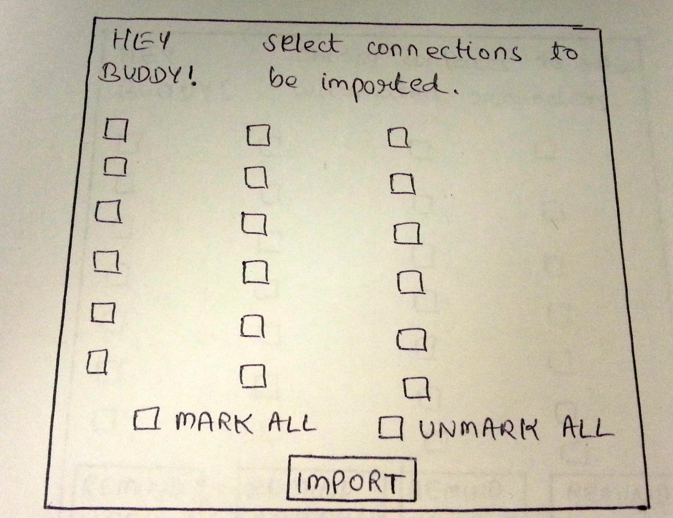

This is the page where you have been redirected by Hey Buddy upon verification of your credentials. It displays all your contacts from the chosen network with checkboxes next to each. You may select some or all of the contacts and click the import icon to start importing them to Hey Buddy. Once you are done importing, you may choose to import from another network or start reaching out to the imported contacts.

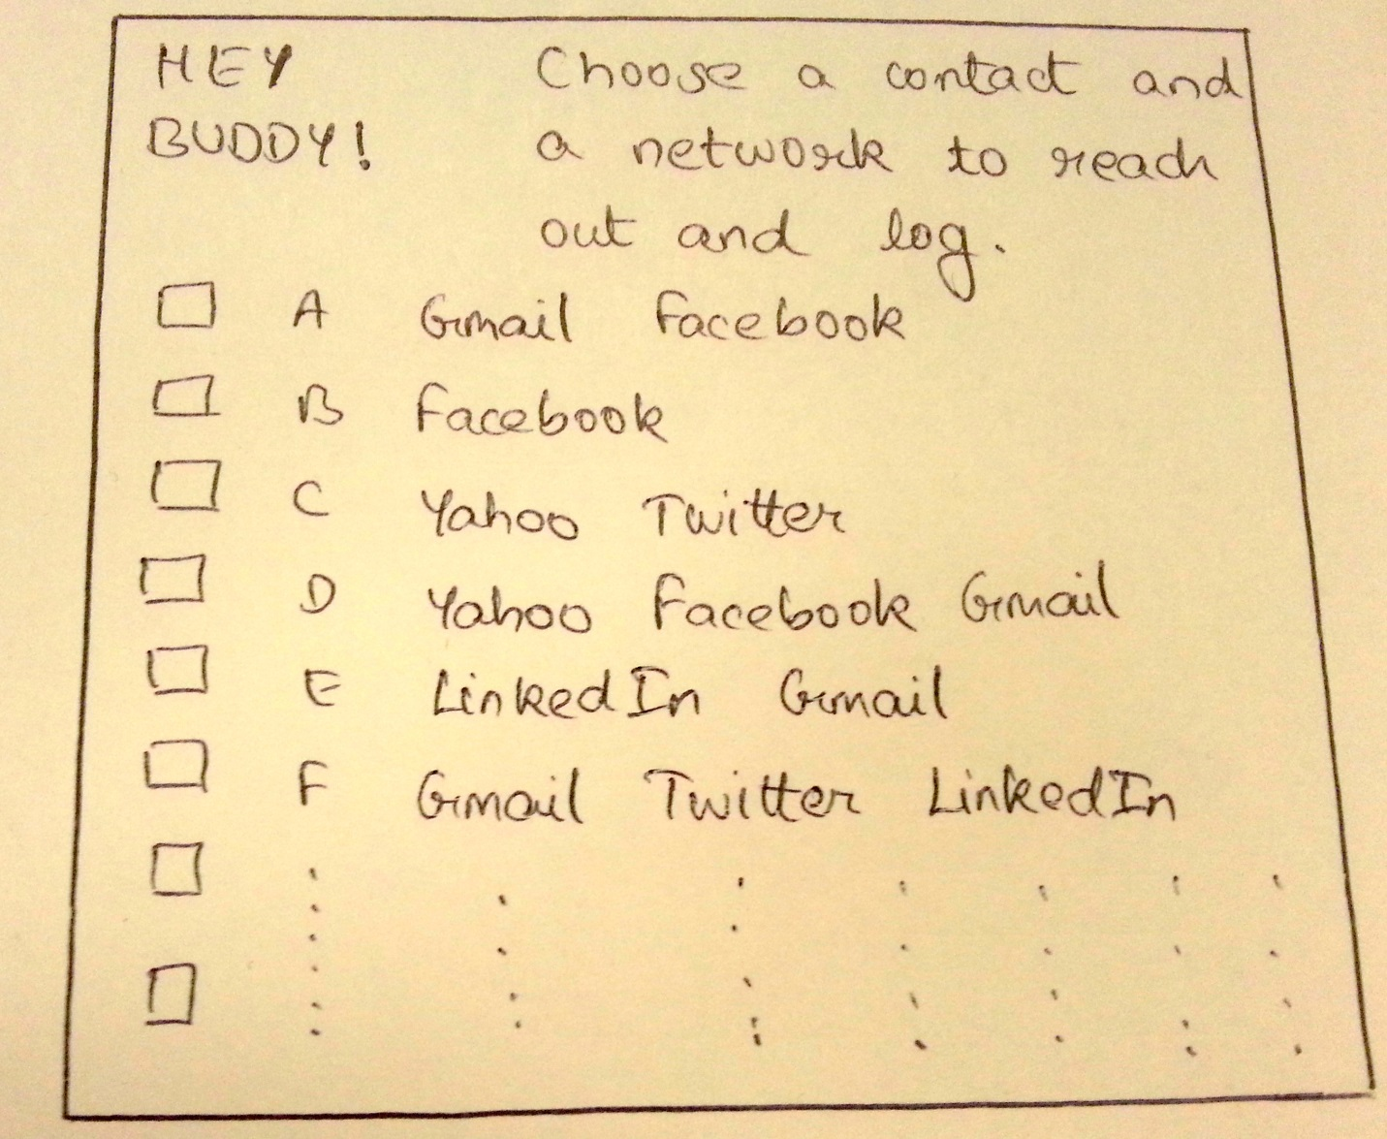

Click on the checkbox next to the contact you wish to reach out to and then click on the mode of communication you would like. If you were connected to the same person through more than one network and you imported their contact from those locations, Hey Buddy would enable you to choose the network you would like to use for communicating. So once you have selected the person to be contacted, click on the network to be used. Once you’re done contacting the person, Hey Buddy would log the date and time you contacted the person, which will help it keep a track of how much time it has been since you last reached out to someone.

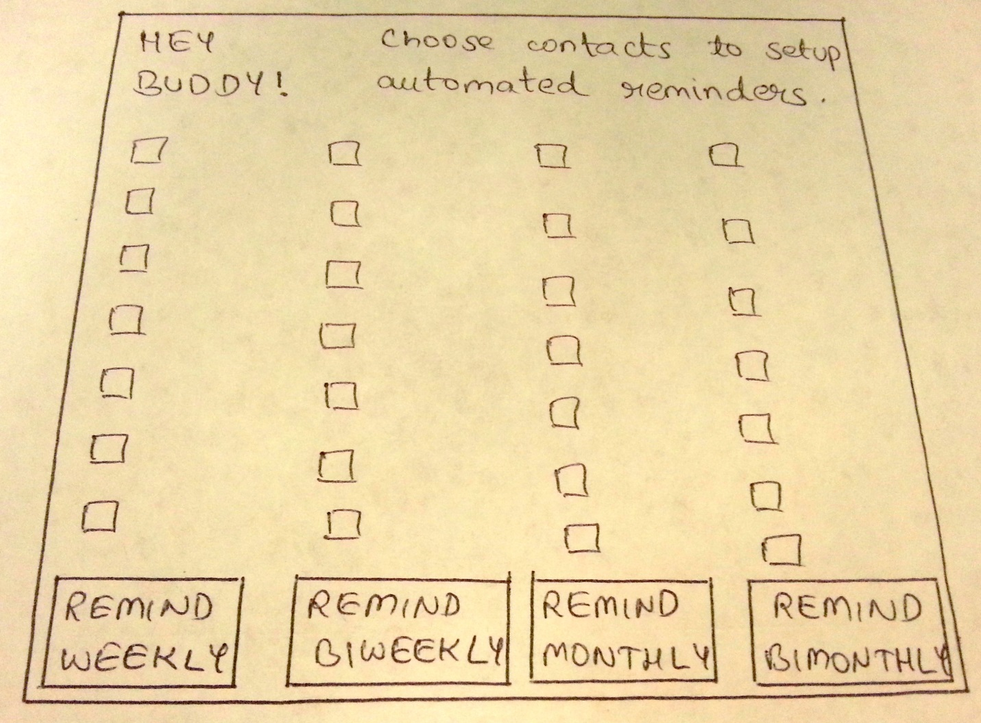

Clicking on the settings tab on the home page would enable you to setup automated reminders for reaching out to specific people. You may select one or more people that you wish to set a reminder for. Using the logged date and time information, hey buddy will send you an email reminder if the last time you reached out was before the setup reminder time duration for that person. For example, if you choose a person and set the reminder as “REMIND BIWEEKLY”, Hey Buddy would send you a reminder email if it has been more than two weeks that you last contacted the person.